CO600 Group Project – Technical report

SNACKMATE

Daniel Stanboulian

Luke Beach

Juned Hussain

**Abstract**

SNACKMATE is a social media platform to share user-created recipes for healthy meals, as well as delivering nutritional information effortlessly. The purpose of SNACKMATE is aimed at the healthy eating and fitness conscience market, to lead a healthy lifestyle by eating nutritional and healthy meals and hit their daily macros.

Our USP is the Recipe Builder, coupled with our Nutrition Genie. These two tools allow users to create their own recipes in a step-by-step form and view the calories/macronutrients of any recipe on the website with a traffic lighting system for data output for easy viewing. Through the power of Nutritionix, SNACKMATE will work out the nutritional information for the user behind the scenes, ensuring the user that creating posts are quick and simple.

**Introduction**

This report will explain all of the processes that took place when creating SNACKMATE. This report will start off with the background and concept behind the idea of SNACKMATE. This report will also include the technical information of the web app, followed by the group decisions and challenges/achievements that took place throughout this project.

**Background/Planning**

Background:

As the years have gone by, people have adopted much busier lives. Nowadays our consumerist society opts for instant gratification, with invents such as fast food and food delivery services merely exacerbating the problem. However, there are many people that are in fact fighting to keep healthy and to avoid unhealthy food.

“The research found that more than two thirds (72%) of shoppers in the UK are buying healthy food – with less salt, sugar, fat or calories.”

This exemplifies how your average shopper is changing, moving to the healthier alternatives that the supermarkets provide. However, the problem is that people are buying healthy, but do they know how to put it to good use? SNACKMATE will ensure these health-conscious shoppers that the healthy food that they’re buying is put to good use.

SNACKMATE hopes to demonstrate to our users that staying healthy really isn’t that hard! People struggle to eat healthy due to not knowing how to cook the dish, or just simply not knowing the ingredients that will make that difference for your health and physique.

SNACKMATE can be used by everyone, but the main audience were targeting is people who are going to the gym/want to live a healthy lifestyle. This application will help people to organize their diet, by tracking calories and nutrition and reach their dream body.

**Planning:**

When it came to planning, we had to discuss many different things. We had to think about ways to keep in contact with each other and to have a way to share what we’ve done in terms of the creation of the web application.

In terms of keeping contact we had to agree on a platform that everyone was comfortable with. In the beginning, we were eager to try out the current industry standard for start-up companies, *Slack*. However, we soon realised that its extensive features and support for multiple ‘channels’ were unnecessary for our needs since we were such a small group. Additionally, the lack of group video calling on a free plan was the straw the broke the camel’s back and made us search for a service that can fulfil our needs. So, instead, we agreed that WhatsApp and Discord (when on our workstations) were the best ways to interact. We primarily used Discord for its (free) group calling features to carry our meetings when not physically in contact with one another. We choose WhatsApp because it’s a service where, we can exchange messages, images as well as Wi-Fi phone calls with ease and the fact that everyone already had it installed.

When it comes to tracking the progress of what everyone has done/contributed, we used multiple platforms. The platforms used were Google Docs, Trello and GitHub. Google Docs was used for the technical report, making it easy for everyone to check over on what has been written, ensuring that the content is relevant to the project.

GitHub was used as our version control system (VCS), this was an invaluable tool for allowing group contribution, keeping an eye on progress and facilitating easy backups. Additionally, with the use of GitHub Pages, it allowed us to host the website for free. Everyone in the group was able to pull(download) the files that the other group members have uploaded, having more of an insight on what they have added or changed. As well as uploading (push) files that you have altered for the other group members to see. This was a very efficient way to check on where everyone was at with the development of the project.

Trello was used as an online scrum board to set tasks for one another, ensuring that everyone had a task to fulfil. Trello was a useful platform as it had the feature to show if someone has completed the task, they set for themselves/or have been given. We split our Trello board into 4 different columns: Essential features, Currently doing, Completed, and Potential. This allowed us to, at a glance, see what features needed to be done and where our time could be best allocated. Consequently, everyone always had something to do, regardless if they had completed their own tasks.

When we came up with the idea of a web application, we needed to think about how we would design the user interface. We made use of storyboards and mock-ups using notepads and software like Balsamiq and Adobe XD that demonstrated the potential user experience, this way we could get a real representation of what SNACKMATE could look like. This helped us to get started with the project early, with everyone able to work at their own pace because we had decided on a group vision of what we wanted the web application to look like.

**Programming Language & Environment**

The programming language that we used was TypeScript (Microsoft’s strictly typed version of JavaScript), coupled with the Angular front-end framework. For the back-end, we initially planned to create a bespoke RESTful API using NodeJS and host it on a platform such as heroku. However, when we realised that our project was mainly a front-end focused application, we began to look for alternatives that were more time-efficient to implement. This led to us opting for Firebase for our backend needs for the web app. We have taken advantage of many of Firebase’s core features, including the Firestore Database, Firestore Storage, as well as the Google Authentication service which we used to register and authenticate users.

IDEs are a personal preference, however, we all leaned towards Visual Studio Code as our personal code editor for the web application due to its incredible flexibility and easy install of extensions such as linters. The Angular framework enabled us to start creating the web application right away, thanks to the zero-step installation and extensive documentation/lessons available on the web. The fact that Angular is a framework made for SPAs (single page apps) means that it is inherently cross-platform, which is ideal for the SNACKMATE project. There is no installation required for the end-user, and at the same time we can offer a near-native performance due to the powerful optimisations and bundling that goes on behind the scenes. This cross-platform support enabled us to create an app like experience for the web app, while also accommodating PC users, although we decided to use a mobile-first approach to the design as most people tend to use their phones for browsing nowadays.

Firebase was used because it is efficient and it's secure when it comes to authentication and database management. Efficiency is key for this particular project as it needs to retrieve the data fast; once the user logs into the app they will be entered into the feed which will display all the images that users have posted. There will be a lot of different images from different user accounts, Firebase ensures us that all of the images, comments and user accounts will be displayed in efficient time, transferring the data from the database to the SNACKMATE feed.

**Design**

The design of SNACKMATE owes its inspiration to other successful social media platforms such as Instagram and Reddit. We wanted a design that is easy to use with a modern feel, clean and sleek. The primary colour of the project is a light shade of red, which we coupled with a white background, which allowed us a certain familiarity with the other social media platforms, while also adding our own unique flavour.

We also wanted a unique way of displaying users’ meals on the feed, so we thought that we would create recipe cards. The recipe cards have the following information: the name of the dish, an image, the author’s username, calories, description, allergens, Nutrition Genie (containing the macros in a traffic light system) and the comment/liking section, as well as a human readable upload date.

The description is where the creator of the recipe has the opportunity to explain why their recipe is great. Limited to 125 characters, it creates a fun yet powerful challenge for users to really sell their recipe in a short description. It is up to the user if they actually hit the character limit, but people are more likely to click on a well thought out description that provokes their attention than a generic one. The Allergens section will display the possible allergens that are in the meal, this way the users are ensured that the meal is safe to eat not leaving any room for uncertainty.

Finally, the section that we believe that will catch the eyes of the user is the Nutrition Genie. This particular section will present all of the nutritional information of the meal such as: Calories, Protein, Carbs and Fat and display them using a traffic light colour coded system.

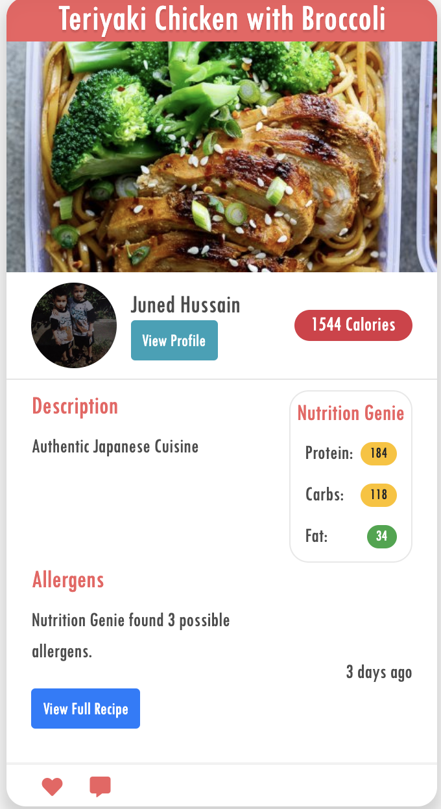

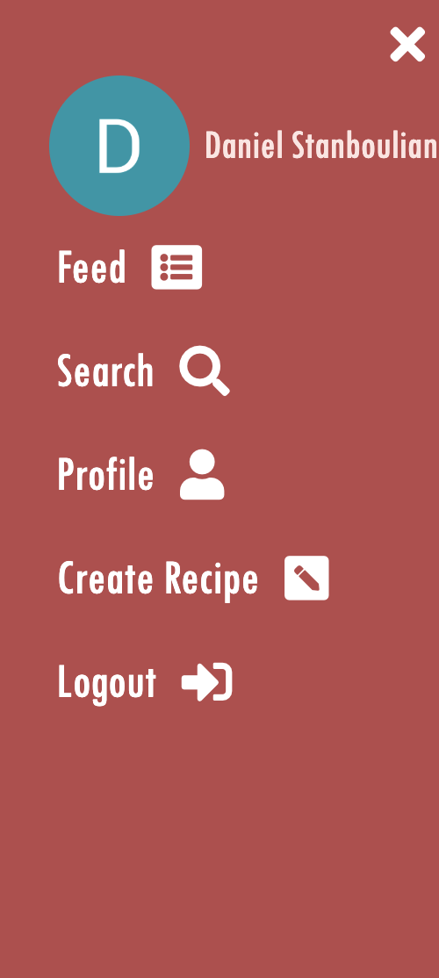In terms of navigation, we thought it would be a good idea to include a sidebar with links to all of the different pages within SNACKMATE. We feel like the navigation of the web app will not interfere with the minimalist design because it is tucked away on the right-hand side and can be summoned whenever the user needs it using the menu button at the top right of the screen.



Attached below are two images of the sidebar, the photo on the right side shows what the button for the sidebar looks like, and on the left side is what the sidebar looks like when extended showing all of the different pages you can visit. The sidebar uses some conditional logic to only display pages such as ‘Create Recipe’ or ‘Log out’ if there is currently a user logged in.

Overall, the representation of SNACKMATE on the computer will give the user a clear view of the SNACKMATE feed (image below). The recipe cards are in rows ensuring that the user can see multiple recipe cards yet having enough space so it’s clear for the user to see. Meanwhile, on mobile, the recipe feed turns into a column view, allowing each recipe to take up the full screen of the device.

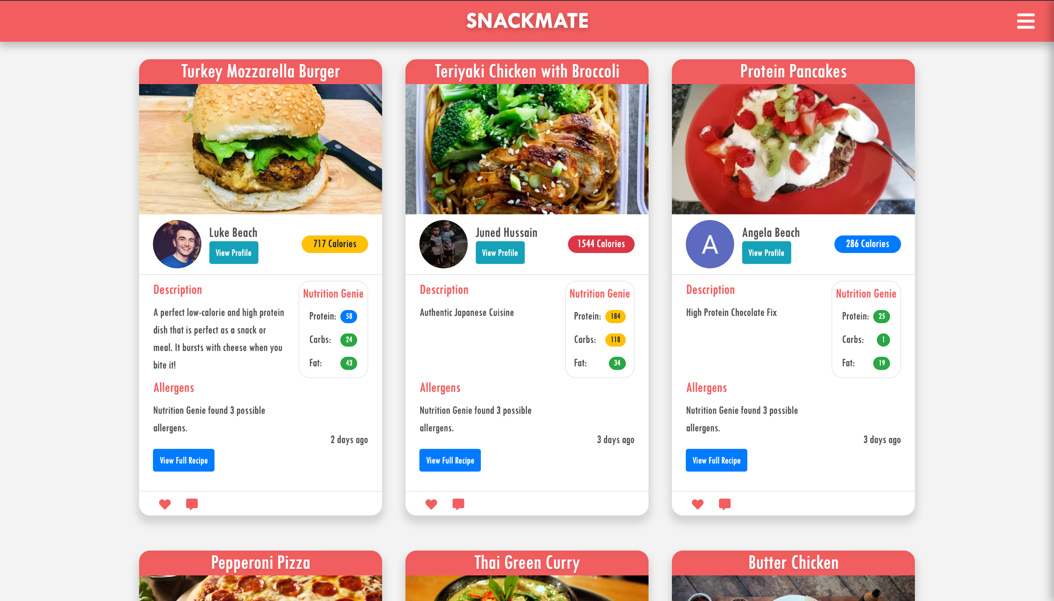

**User story**

During the creation stages of SNACKMATE we came up with a user story, on an ideal scenario when creating a recipe for the first time:

1. A user is feeling hungry and wants to eat something healthy.

2. User types [www.Snackmate.co.uk](http://www.snackmate.co.uk) into the search bar.

3. They will then access the feed, filled with different recipe cards created by the users of the platform.

4. User will need to log into their Gmail account, this is done by clicking the sidebar tab and will show the login link

5. User logs into their Gmail account

6. Once done, the user will be able to create a recipe and share with the world of SNACKMATE.

7. User will click the create recipe option via the side tab

8. User will be redirected to the create recipe page, which contains three sections

9. The user will firstly fill in the summary of the dish, giving it a name, a description of the recipe and finally upload a picture of their food.

10.   Secondly, they will type the list of ingredients that are used within the dish (2nd section)

11.  Finally, the user will list down the cooking instructions on how to cook their meal, then will submit their recipe into the SNACKMATE feed.

**External sources/API**

A big part of our web application, what makes it unique, is that users can enter all their ingredients into the ingredients section of the ‘create recipe’ page and it will give all the nutritional information about the dish created. In order for us to provide this particular service, we needed a source that will provide the users with the nutritional information. We decided that the Nutritionix API would fit this particular criterion, as it will give the user the capability to enter the amount of the ingredient they used and will give the nutritional information about that ingredient. More specifically the nutritional information that will be produced, will be the number of calories, protein, carbs and fat. Having nutritional information like this will ensure the user that if the dish they are looking at really does match their needs when it comes to fitness.

**Challenges**

**Limitations**

Despite the positives of our web application, there are a few limitations. One of them being no real log-in page, meaning that the user does not have the freedom to pick any other authentication system other than Google, which is the default authentication system for SNACKMATE. This is a limitation because some users may not have a Gmail account, meaning that they will have to go and create one for themselves to gain access to the service which may be time consuming or deterring.

We are using the ‘hacker’ Nutritonix plan, which is essentially the free plan. As a result of only using the ‘hacker’ plan, it can only allow up to 200 requests per day meaning that there is a limit on the number of users that can use the site. In addition, there can only be two active users that can use the nutritionix service, meaning that users have to wait if there are already two active users, which can also be time consuming.

Finally, to make use of the SNACKMATE service the user will need an internet connection, as it’s a web app. This will be a limitation for those without an internet connection as they won’t be able to use SNACKMATE.

**Aims**

Our aim is to inspire people to stay healthy, as well as adding to their imagination when it comes to food. We want to encourage people to create healthy meals for themselves and to share it in the with the world of SNACKMATE. This way, it will also inspire others as well as yourself.

We believe that SNACKMATE can support a lot of people, in all kinds of situations. An example would be University students, which are mostly teenagers that have moved away from their home. Anyone who has gone to university will realise the struggle when it comes to looking after yourself, not having the support that you received at home from your parents, especially when it comes to cooking meals. SNACKMATE will ease the struggle considerably as it will be constantly giving people different ideas about what you can do to eat healthy. This way students will know what to look for when going to supermarkets due to the user they got the meal idea off will provide a full recipe page that will show how to cook these meals.

**Future development**

When it comes to future development, we want to create a mobile application for SNACKMATE. We feel that SNACKMATE has the potential to become one of the most popular applications on Apple’s App Store. This will be a great way for exposing SNACKMATE to the public, letting everyone know about our excellent, unique service. Thanks to Angular this makes this particular development a real possibility.

Another possible development for the web application would be adding new types of functionality and features. This way it will keep SNACKMATE a modern service as well as keeping the public keen, being intrigued on the different types of things you can do when using the service.

Upgrading the plan on the API we are using, Nutritionix, would be key for SNACKMATE’s future development. The reason is because the plan that were on limits the number of users that can make use of the nutritionix service, which is not ideal if we want to expand our service. Including the next plan will enable us to have lots of users in the country, potentially worldwide. Upgrading the nutritionix plan will also encourage us more to create the application for SNACKMATE as it would be available to all iPhone users worldwide.

**Quality assurance**

The quality of the SNACKMATE service was assured by getting different users to try out the web app. Once they have tried out the service, feedback was given by them, mostly positive but there were some negative comments made. The positive comments were people liking the idea behind the ‘nutrition genie’ how it gave the user nutritional information about their meal, suggesting that it will be ‘incredibly useful when it comes to creating meals that are low in calories, but high in protein’.

The negative comments that were made about the web application was that there was only one type of authentication system, which is Gmail. One of the external users didn’t have a Gmail account and had to go and create one for themselves which did leave them with some frustration. Otherwise the user did say everything else about the web app was good quality, saying that the design and ideas were impressive yet also useful.

**Conclusions**

Project overview:

We as a group created this original idea of SNACKMATE. The aim was to create a web app service that will aid people in terms of eating healthy and managing their diet to get their dream body. The idea behind having a web app is that there is no limit to functionality and features when compared to mobile apps, ensuring that the user experience is at the highest level possible.

**Final product**

We have created a web application that uses the Nutritionix API to get the nutritional information from the created dishes that the users of SNACKMATE have made. This is done by simply entering the ingredients that were used and how much of it was used. The features of the web application were built up of research and discussions with users that have used SNACKMATE. Ensuring that the web application reaches its full potential.

**Future improvements**

Making SNACKMATE a mobile app:

Making SNACKMATE a mobile application on Apple’s App store. This will make room for SNACKMATE’s expansion, meaning that people all over the world will have the capability to gain access to the service. We yet have to decide whether the application will have a fee or not.

Adding new features and functionality:

We plan to add new features and functionality to SNACKMATE, making sure that the service is keeping up to date with the new technologies that are getting released in the upcoming future. Constantly looking for ways to update the web app, ensuring that the user experience has reached its full potential.

Upgrading the Nutritionix plan:

As a group we hope to upgrade the Nutritionix plan so the web application can hold more than two active users. This will be a big part of SNACKMATES expansion, as it will allow a lot more people to use the Nutritionix service, gaining as many users as possible. Once we have upgraded the plan, we can potentially turn SNACKMATE into a successful business, as upgrading the plan of the API it will give us a lot more reason to turn it into a mobile application, which we can potentially charge people for.

Acknowledgements:

Many thanks go to our supervisor Ian Utting, who met with us every week to ensure that we were on the right track with the project. As well as giving advice on where we could improve and giving us several ideas on how we could improve the user experience of the service. We would also like to thank Nutritionix for making an exceptional service available to us, in addition to the API BEING FREE OF charge which is very ideal for us students.

**Bibliography:**

<https://www.talkingretail.com/news/industry-news/uk-shoppers-increasingly-buying-healthy-food-finds-report-03-10-2017/>

(date accessed: 27th march 2019)